Appendix A: Harmonized Protocol for SCORE Gaining and Sustaining Control Studies

Overall goal: The overall goal of this project is to provide an evidence base for program decisions about mass drug administration (MDA) to gain and sustain control of Schistosoma haematobium (Sh) and Schistosoma mansoni (Sm) infections. The four studies being funded are:
- Study 1 Sh: Study 1 for S. haematobium will compare MDA delivery strategies in study communities/villages with baseline prevalences among school children of 10-24% by filtration or 5-20% by dipstick.
- Study 2 Sh: Study 2 for S. haematobium will compare approaches in study areas with prevalences among school children of >25% by filtration or >21% by dipstick.
- Study 1 Sm: Study 1 for S. mansoni will compare MDA delivery strategies in study communities/villages with baseline prevalences among school children of 10-24% by stool examination.
- Study 2 Sm: Study 2 for S. mansoni will compare MDA delivery strategies in study communities/villages with baseline prevalences among school children of >25% by stool examination.

Study overview: We anticipate projects will be of 5 years duration − 4 years of intervention, with the final data collection occurring in the fifth year. It is likely that MDA will be provided in the fifth year in many communities, but data on the impact of the fifth year of treatment will not be collected as part of SCORE. However, to ensure flexibility to incorporate results of ongoing research and address other changes that may occur during the study period, we will plan to conduct a mid-course evaluation after Year 2, the results of which may affect study plans and funding decisions related to years 4 and 5 of the project. Any possible funding changes will be openly discussed well in advance, and will include significant investigator input.

Research questions and study components

Primary question
What strategy for mass drug administration (MDA) provides the best balance in terms of cost and reductions in prevalence and intensity of S. haematobium or S. mansoni in school-aged children after 4 years of intervention? Specifically, these studies are designed to answer the questions:
- Sh1: In communities/villages with S. haematobium baseline prevalence 10-24% by filtration or 5-20% by dipstick, what combination of annual school-based treatment (SBT) and drug holidays yields the best outcomes for the lowest cost?
- Sh2: In communities/villages with S. haematobium baseline prevalence >=25% by filtration or >=21% by dipstick,
- Is there a difference between doing community-wide treatment (CWT) in Years 1 and 2 vs. SBT in those years in terms of parasitologic outcomes after four years?
- After the first two years, what additional benefit accrues from annual MDA vs. providing a drug holiday, and at what cost?
- What is the impact of alternating years of MDA and drug holidays?
- Sm1: In communities/villages with S. mansoni baseline prevalence 10-24% by 3 stool examinations with 2 Kato-Katz slides per stool per child, what combination of annual SBT and drug holidays yields the best outcomes for the lowest cost?
- Sm2: In communities/villages with S. mansoni baseline prevalence >=25% by 3 stool examinations with 2 Kato-Katz slides per stool per child,
- Is there a difference between doing CWT in Years 1 and 2 vs. SBT in those years in terms of parasitologic outcomes after four years?
- After the first two years, what additional benefit accrues from annual MDA vs. providing a drug holiday, and at what cost?
- What is the impact of alternating years of MDA and drug holidays?

Secondary questions
- What are the factors that determine the effectiveness of MDA − can we develop reasonable measures of force of transmission that can be used to make decisions about the most cost-effective means of lowering prevalence and transmission in a given village?

Study components
1. Determine possible study sites. Use historic and other data to identify communities/villages that are likely to meet criteria for inclusion in the studies. For purposes of this protocol, a study community or village must have a primary school, because several arms of the study are school-based and every participating community must be eligible to be randomized to any of the study arms. However, a study community may have more than one school. If two nearby communities have schools with less than 100 children per school, but they are similar, they can be combined for purposes of this study and be considered as one study community. Two nearby communities that share water sources and/or whose schools have overlapping catchment areas should not be considered two villages for purposes of this study; one of the two should be chosen, although treatment of populations from both villages during the MDA campaign is encouraged, especially if it could create public relations or ethical concerns not to do so.

There is no pre-set population requirement for the size of a community/village, as long as it includes at least 100 schoolchildren between 9 and 12 years of age. In general, preference is for places that have not recently received MDA. If communities/villages have been previously treated, historic treatment data should be included where available. To the extent possible, study communities/villages should be as similar as possible in characteristics that could affect transmission dynamics, including history of past treatment, water sources, etc.

In the case of communities that have more than one school, for determining eligibility for the study (and for follow-up measurements), it is acceptable to choose one school for survey purposes. This school might be selected based on size, ease of working with the school, or expected rates of infection in school-children. However, MDA should be provided to all schools in the community if it is randomized to the SBT arm.

2. Gain community support for potential study involvement. Conduct initial sensitization of communities/villages to gain support for testing school children to determine community eligibility for the study. A simple standard approach will be developed to capture what activities are conducted to achieve sensitization.

3. Determine eligibility. Determine eligibility of communities/villages by testing 50 school children in classes that include those ages 13-14. Each Study 1 will require a total of 75 villages (25 per study arm), and each Study 2 will require 150 villages (25 per study arm). Children who test positive in this initial survey should be treated. This will involve examining a mid-day urine in Sh villages, using either dipsticks or 2 filtrations of 10 ml each. In Sm villages this will involve testing a single stool, examining 2 slides per stool.

4. Randomize. After an adequate number of eligible communities/villages are identified, they will need to be randomly assigned to the arms of the study − 3 arms for a Study 1 and 6 arms for a Study 2. Regardless of the outcome of randomization, for example, an uneven distribution of a particular factor, villages may not be re-randomized.

Study 1 Year 1 Year 2 Year 3 Year 4
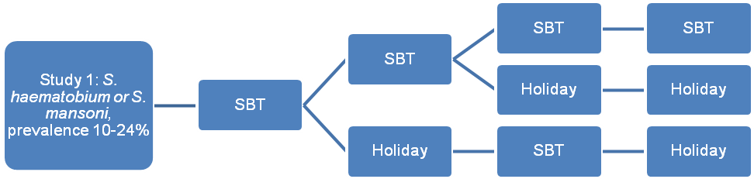
Arm 1
Arm 2
Arm 3

Study 2 Year 1 Year 2 Year 3 Year 4

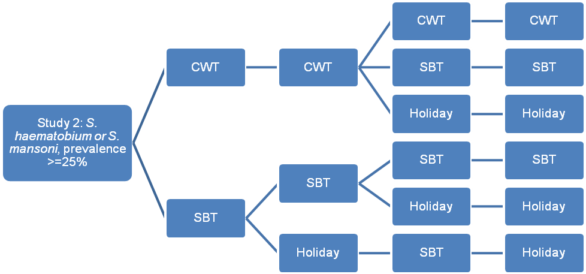
Arm 1
Arm 2
Arm 3
Arm 4
Arm 5
Arm 6

There will be no stratification for randomization of Sh1 and Sm1 communities/villages. Sh2 and Sm2 communities/villages will be randomized with stratification by prevalence on initial screening using Proc Plan, according to an agreed-to protocol.

5. Identify villages for layered studies (Sh2 and Sm2 only). Layered studies include subtle morbidity, snail, and parasite genetics evaluations. Investigators funded under this RFP who are conducting Sh2 and Sm2 studies will also be funded to conduct subtle morbidity studies. Investigators funded under this RFP should participate with investigators conducting snail and schistosome population genetics studies to ensure snail collection and plans for parasite collection are in place before MDA.

6. Sensitize communities. A greater level of effort will be required to engage eligible communities in the full, multi-year study than was required for the initial eligibility survey. A simple standard approach will be developed to capture what activities are conducted to achieve sensitization.

7. Train workers. This includes training on data collection, drug delivery, reporting of adverse events, etc. Incentives may be paid in accordance with local practices and practices of non-government organizations in the area.

8. Collect baseline and Year 5 data on the study communities/village. Forms will be provided for use by all studies that will facilitate collection, either by key informants, door-to-door census, or other methods, about important issues that could affect transmission for use at the beginning of the study and in Year 5. These forms will be developed as a collaborative process. They will include such information as water sources, sanitation, occupations, use of antimalarial drugs, etc. It will be more important to have detailed information (e.g., collected at the individual level, if possible) in villages/communities where subtle morbidity studies are being conducted.

9. Conduct a census. A census will be conducted, or quality census data collected via other means, in Year 1 in all selected communities/villages to provide a baseline for estimating coverage. In Sh1 and Sm1 communities, the census may be limited to children 4-18 years of age and their heads of households and parents. In some places, reasonably accurate census data may already be available. For example, in Kenya, community strategy staff may have data already, and in some cases it may be appropriate to use a national census, with or without adjustment. Door-to-door distributors could also potentially conduct the census. If a door-to-door census is being conducted, it is recommended to also get information about latrines and water sources using standard questions (to be provided).

10. Annually collect information about events that may affect study outcomes. Because of the complexity of schistosomiasis control, investigators will need to track changes in multiple factors that could affect study outcomes. Randomization is unlikely to address all of these. Factors of concern include but are not limited to changes in sanitation and water supply, unusual weather (e.g. drought and floods) or the effects of climate change, economic development, new dams, political instability or local changes in leadership that affect MDA efforts, changes in the existing health system, community attitudes and behavior related to health and health care seeking, and other programs that are introduced during the study period. A form will be developed for collecting data on an annual basis. This will include suggestions for how to collect information about malaria treatment.

11. Evaluate schistosomiasis prevalence and intensity at baseline and then annually. The most important outcomes for the study relate to schistosomiasis prevalence and intensity in the population in all years in which MDA is conducted.
The following populations will be tested:
- In all studies: 100 children in the classes that include those 9-12 years of age. If there are more than 100 children in this age range, select children randomly for testing. For children in this age range in Sm communities, 3 stools will be examined. These prevalence and intensity evaluations will be done each year preceding MDA. (They will not be conducted in communities having a drug holiday.)
- In all studies: 100 first year students in the first and fifth years. For Sm1 and Sm2 studies, it is acceptable to examine 1 stool per child, except in communities doing subtle morbidity studies, where 3 stools per child will be collected. If samples for 100 first year students cannot be obtained, test as many as possible. Do not add age groups.
- In Sh2 and Sm2 studies: 50 adults ages 20-55 years from the community in the first and fifth years. For Sm2 studies, it is acceptable to examine 1 stool per adult, except in communities doing subtle morbidity studies, where 3 stools per adult will be collected. A variety of processes to identify these adults will be acceptable. A subgroup will work to articulate these. They could range from a random sample of adults identified through the census to a random selection of areas within the study village and random selection of adults from within those, to other options. Only one adult per household should be selected, and pregnant women are eligible. SCORE does not require adults to be tested in Sh1 and Sm1 studies.

In Sh1 and Sh2 studies, a single mid-day urine should be tested, with eggs quantified and recorded separately for two 10-ml filtrations. In Sm1 and Sm2 studies, 2 slides per stool should be examined using Kato-Katz. It is acceptable to collect stools for Sm1 and Sm2 studies but defer reading them until later.

12. Conduct MDA and record serious adverse experiences (SAE). Praziquantel (PZQ) will be provided as a single dose of 40 mg/kg, using a dose pole, using the approach defined by the study arm. Normal PZQ treatment exclusion criteria apply. MDA will not be provided during drug holidays.

School-based treatment (SBT)
During school-based treatment, it is expected that PZQ will be administered by trained teachers to all primary school-age children. Children in all schools in the community should be treated, even if they are not in a school where children are being tested. Any time school-based treatment is occurring, practical efforts should be made to treat non-school attendees who span the same age range as children who are in school e.g. community sensitization and mobilization efforts, radio announcements, and other Information, Education, and Communication strategies. However, major treatment strategies outside the school-based venue should not be implemented. Investigators should document school attendance rates throughout the study community.

Community-wide treatment (CWT)
CWT for these SCORE studies means providing treatment to the entire eligible population, which only excludes children under 4 years of age or under 94 cm in height, in the study community. A checklist will be provided that can be used to describe the ways in which CWT is provided. If coverage after the first attempt is less than 75%, additional efforts should be made to increase the coverage. It is essential that treatment be directly observed.

Regardless of method of distribution, those providing PZQ will be required to keep records consisting of names, ID numbers, age, sex and height (for children), numbers of tablets, etc. Systems must be in place for responding to and reporting SAEs. In villages receiving SBT, SAEs should be reported to teachers. In villages receiving CWT, SAEs should be reported to community distributors. Teachers and community distributors, respectively, should be trained on whom to contact should there be a serious SAE. Reporting will be in accordance with WHO procedures. Minor complaints and side effects that are not serious will not be measured.

Sample forms will be provided for recording information about who receives treatment. These will include name, age, weight, height, etc.

It is recognized that some populations are migratory. There will not be special attempts to follow up or otherwise reach migrant populations.

Excess PZQ will not be ordered for purposes of leaving in clinics. However, partially used tins will be left with teachers for use during the year as needed or for children not in attendance the day of treatment.

13. Estimate coverage and achieve targets. Estimations of coverage should use an appropriate denominator, derived from census data. The goal for MDA in this study is 100% coverage. In agreeing to do this study, researchers are committing to achieve at least 90% coverage of children enrolled in school and at least 75% coverage of school-aged children overall. For CWT, the investigators are committing to achieve at least 75% coverage of the entire community. This may require repeated efforts if it is not achieved through the first round of intervention. If coverage is less than 100%, the reasons for this should be determined and recorded.

14. In Year 2, estimate costs. In Year 2, investigators will be expected to collect data using a standard protocol that will be established with investigator input. Sites that have already been collecting data as a part of the Gates-funded effort to understand the costs of integrated programs for neglected tropical diseases will be able to use much of the data they have already collected as the basis for the cost component of this study. However, some additional variables may need to be collected, and this will be discussed in the first annual meeting, during the development of the standard data collection protocol with investigators.

15. Share samples and data. All SCORE investigators will be expected to collaborate and to facilitate the collection, analysis and sharing of samples and data. Investigators are not expected to include these parallel studies in their budgets, but should be aware of them and may need to provide budget estimates to applicants for these other funds and to SCORE, for example, to collect additional samples.

16. Disseminate results. Funded investigators will be encouraged to publish their findings as appropriate to ensure public access. They will be expected to agree to provide their data analysis and publication plans to and to work cooperatively with the SCORE Secretariat and other SCORE-funded investigators. Draft manuscripts should be submitted to the SCORE Secretariat at least 2 weeks prior to submission to a journal for publication in order to ensure optimal coordination.

